Meet Lisa
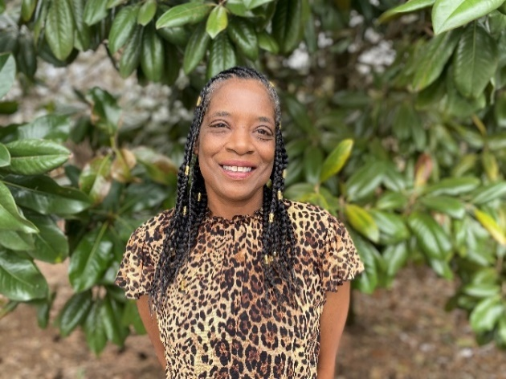
Good Neighbor
Lisa was born in Cincinnati, Ohio. She and her friends spent a lot of time at the recreational center in their hometown. In her early teens, Lisa, her older brother, and mother relocated to Lebanon, Tennessee to be closer to family. Although they experienced a lot of challenges along the way, there was a lot of love and support. Just a few years after moving to Tennessee, Lisa lost her mom due to an extended illness.
Upon graduating from high school, Lisa began her career and started a family. She has been with Genesco for the last nineteen years. Lisa has two children and three grandchildren. One of her greatest joys has been watching her children grow and become parents themselves. Lisa was married for eighteen years and even though they eventually separated, the family remained very close.
Growing up, Lisa had always lived in apartments. She dreamt of one day owning her own home. However, with the continuous rise in housing prices, she felt as though it wasn’t going to happen. It was Lisa’s daughter that encouraged her to consider the Rutherford County Habitat for Humanity. Lisa knew about Habitat but did not know how to go about applying for the program. After doing a little research, and discovering the office was down the street from her apartment, she decided to apply for the RCHFH Homeownership program.
When Lisa was notified that she had been accepted into the program, she was overcome with emotion! “I honestly couldn’t believe it and still can’t,” she said smiling. “I never thought I would get to experience something like this!” Lisa is enjoying her homeownership journey and being surrounded by caring people at RCHFH that really want to see her dream come true. She is truly looking forward to what each phase of the program has to offer and getting one step closer to owning her own home.
Once her home is built and she gets settled in, Lisa has several goals and plans. “I am excited about decorating my home, having my family visit, and getting a dog,” she said smiling. “I hope to be a good neighbor and help create a close community in the Legacy Pointe neighborhood.”
Lisa is extremely grateful to everyone who supports the RCHFH mission to create opportunities for those dreaming of one day owning their own home.

